**Pratical 3: Demonstration to INSET,UPDATE and DELETE Record in Table**

**Student Name:- Rushikesh Divakar Borale Roll No :-23**

**Div :- ‘A’ Batch No:-B1**

**USE ;**

insert into student ( empid, ename , address, salary) values (9,'rutu','jalgoan',2005);

select * from student;

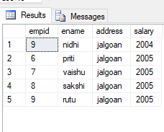

select * from student;

update student set ename='priti' where empid=6;

update student set ename='sakshi' where empid=7;

update student set ename='vaishu' where empid=8;

update student set ename='rutu' where empid=9

delete from student where empid=8

OUTPUT

